**Why is E-Waste Recycling Important? Excellent Illustrations!**

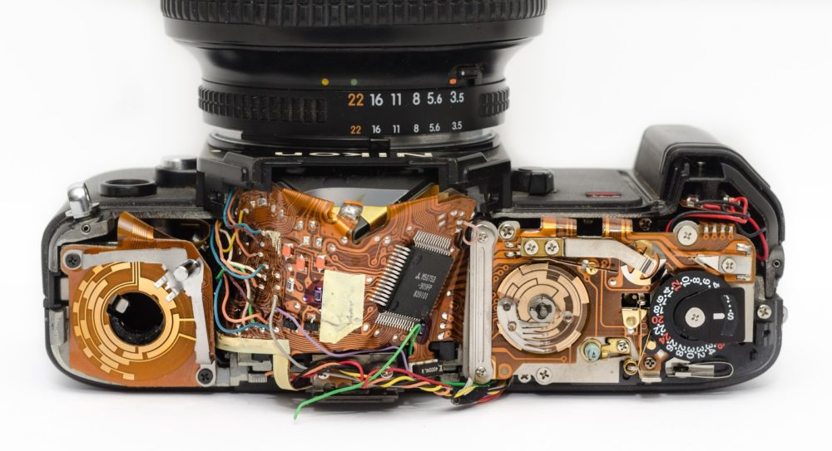

So, why is e-waste recycling important? There are numerous compelling reasons to begin recycling your e-waste right now.

Recycling, like exercising and eating well, is a type of behaviour. Some people are more dedicated to achieving these objectives than others.

But one thing we do know is that, like exercise and healthy eating, recycling is something that most people support, at least in theory. The vast majority of people appear to embrace the concept that recycling items that you no longer want rather than throwing them away provides environmental and ecological benefits.

In a poll done by Ipsos Public Affairs, only 3% of respondents indicated they don't think their recycling efforts will make a difference, and only 2% said they don't think recycling is necessary.

However, more than double that number — 6% – said something completely different. They claim they don't recycle because they aren't aware what is and isn't recyclable.

That's an important conclusion since it explains not just why recycling rates have stayed constant, but also what may be done to increase them. It is critical to educate people about the benefits of recycling (such as saving the environment). But a lot more practical and common-sense discussion is also necessary: teaching people about what goods they're now throwing that may and should be recycled.

And this is especially true for one of the most pressing recycling concerns: the need to enhance recycling rates for used electronics, which are rapidly becoming a major environmental concern as the volume of discarded electronics increases year after year throughout the world.

**What Is E-Waste and How Is It Defined?**



When people hear the word "recycling," they usually think of soda cans, water bottles, cardboard boxes, or newspapers, which are all common home objects. Other goods, such as toothbrushes, eyeglasses, toilets, and pharmaceutical drugs, may not come to mind right away. The list might go on forever.

We also want to recycle each of these products to avert an ecological calamity in our landfills, which could occur if we throw everything out. We must acknowledge the role that recycling plays in assisting us in creating new items from the parts of old ones.

Something more that should be included on the list is electronics. They're one of the items we want to make sure we recycle since the consequences would be disastrous for the environment. Used electronics are known to contain poisons such as mercury and lead. If carelessly disposed of, these chemicals can contaminate our land and water, posing a threat to both humans and wildlife. Recycling keeps toxic equipment out of landfills and guarantees that valuable components can be reused to create new goods.

However, many individuals are unaware of how many different types of electronics fall into the "recyclable" category.

But it's critical that the public is aware of how many different items can be recycled, as well as the broad definition of e-waste. Each year, Americans toss away 9.4 million tonnes of electronics, making the United States the world's leading producer of e-waste. And far too many people in the United States have no idea what e-waste is, how it is characterised, or what should be recycled.

It is critical to educate the general population on these issues.

Because of environmental concerns, certain states, such as New York and California, prohibit e-waste from being disposed of in community landfills and instead require recycling.

**So, what exactly is e-waste?**

Electronic garbage is discarded electronics that have the potential to harm our environment if improperly disposed of, and it should be emphasised that electronic waste is one of the fastest growing components of our nation's waste stream. Any electronic item that is broken, can no longer be utilised, or has become old or obsolete is included in this category.

And in an era when technology is improving nearly every electronic gadget that consumers own, we know that the number of devices we trash each year will continue to rise.

In New York, it is strictly prohibited to discard devices that contain those ecologically hazardous elements. Flat-screen televisions, monitors, computers, laptops, mouse, keyboards, tiny servers, printers and scanners, tablets, MP3 players, VCRs, DVD players, fax machines, video game consoles, and cable/satellite boxes are all included in this category.

Cell phones, smartphones, pagers, stereos, radios, landline telephones, cameras, and CD players are all examples of e-waste. All smart devices, from iPhones to iPads, Apple Watches, Fitbits, Kindles, Nooks, and Amazon Fire Tablets; Virtual Reality (VR) gear; Virtual Assistants; Electric scooters; and more have recently been added to the list as electronics manufacturers become more sophisticated.

You can bet that as soon as a new device is produced, a new and even more innovative model will be released within months, compelling us to replace the now-outdated version.

**What Are Some Other E-Waste Examples?**

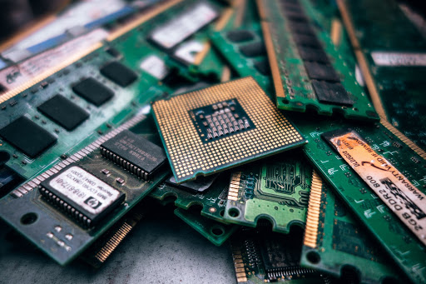

E-waste includes not just the gadgets we use to conduct Google searches, browse the Internet, and send messages, but also various sorts of ICT (Information and Communications Technologies) and telecommunications equipment.

Photocopying equipment and pocket and desk calculators are examples of office electronics, as are automatic dispensers for hot drinks, bottles or cans, and ATMs.

Refrigerators, freezers, washing machines, dishwashing machines, microwaves, electric heating appliances, electric hotplates, electric radiators, electric fans, air conditioner equipment, and exhaust ventilation are among the items on the list.

Vacuum cleaners, carpet sweepers, water dispensers, toasters, fryers, electric knives, clocks, hair dryers, and sewing machines are examples of smaller domestic equipment that would fit in. The list includes fluorescent tubes, compact fluorescent lamps, high intensity and discharge lights, as well as the way we light our homes.

Go outdoors and find your tool shed. More goods can be found there, such as milling, sanding, grinding, sawing, cutting, shearing, and drilling equipment, as well as welding, soldering, mowing, and other gardening tools.

If you have kids, chances are they have some of the goods on this list, such as electric trains or car racing sets, handheld video games, and sports equipment with electronic components.

If you've just visited your doctor's office, chances are that medical equipment such as scanners, stethoscopes, pulmonary ventilators, and equipment for radiation, cardiology, and dialysis is on the list.

That's a lengthy list, and it's only getting longer as manufacturers invest in "smart technology" that allows machines to undertake tasks that we used to do by hand. And the one thing that these consumer and commercial electronic devices have in common is that we no longer want it — the product is nearing or past its useful life.

It's probably e-waste if you can plug it into an outlet or if it contains circuit boards or chips.

Recycling has become a clear alternative for reversing the negative worldwide impact that e-waste has on our environment when it takes up space in a landfill. People on the outside can't see the potentially toxic components inside electronics, such as cadmium, beryllium, arsenic, or brominated flame retardants, so they appear safe. Any of these can be harmful if you are exposed to them.

We also know that millions of tonnes of precious materials that could be salvaged and utilised for new goods are lost when electrical and electronic products are disposed of in landfills.

Another thing to bear in mind is the 18-month period. That is how long the average American retains his or her cellphone.

**Why is E-Waste Recycling Important?**

It's critical to keep hammering home that idea. Electronics that are discarded rather being recycled cause more harm than benefit.

The solution is to hand such items over to a reputable company like [Recycle Pro](https://recyclepro.co.uk/), which has years of expertise recycling electronic products in an environmentally acceptable manner.